Nigeria’s Whitewashed Heads of State;

The Kano Emperors (1)


Muhammed Adedeji Akinyemi
May 11, 2020·16 min read

By: Akinyemi Muhammed
On January 15 1966, Nigeria suffered its first military coup. The military coup was erroneously tagged an Igbo coup because most of the coup plotters were Majors from the East (even though most grew up in the north and spoke Hausa better than Igbo), and in July 1966, there was a ‘rematch’. Aggrieved northern soldiers who felt they needed to avenge the death of their top soldiers and politicians killed in the January coup started to threaten mutiny.
The suspicion was aggravated by the infamous Unification Decree; Decree 34 announced by Nigeria’s Head of State (HOS) Aguiyi Ironsi, an Igbo man. The decree aimed to eliminate regionalism in Nigeria, by enforcing a strong central government (remnants of this decree is still found in Nigeria’s federalism structure, empowering the central government above other units). Decree 34 came at the wrong time, from the wrong person. Northerners thought it was an attempt to take regional power from them and give it to an Igbo man, and that the January coup was all along an Igbo plan to take over Nigeria. Fresh from the wounds of their slain leaders, all Northerners regardless of ethnicity or religion united for vendetta.

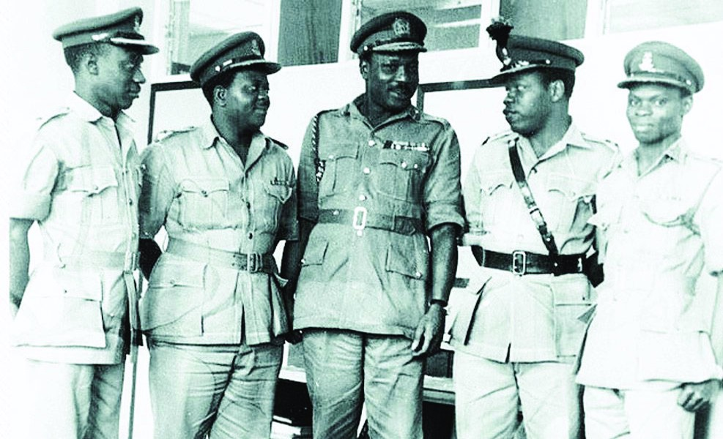
• General Aguiyi-Ironsi (middle), Major Kastina (left), Lt. Col. Fajuyi, Lt. Col, Ojukwu and Lt. Col Ejoor at the State House, Lagos.
Despite being warned of an impending counter-coup, Ironsi paid lip service to it. Why not? He was surrounded by Northern officers in his military council, and he had been more Northern than he was an Eastern man. Ironsi showed loyalty to Tafawa Balewa (to the detriment of Azikiwe) and Ahmadu Bello while they were alive, and continued to display loyalty to the North. But it was not enough; to the angry Northern soldiers, a baby crocodile was still a crocodile, and as long as it was from the East, they were not safe.
Northern Nigeria Lieutenants like Abacha, Shelleng, Dambo, Wali, Jega, were on the neck of the most senior Northern officer, Lt-Colonel Gowon that unless the top officers took action to revenge their slain politicians and soldiers, they would. When Gowon took no step towards avenging them, the soldiers turned to Inspector of Signals, Lt-Colonel Murtala Muhammed, who became the de-facto leader of the revenge action. He was aided by Majors Martin Adamu and Theophilus Danjuma.

Meet Murtala R. Muhammed

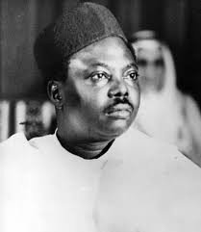
Murtala was born in Kano on November 8, 1938, to Risqua Muhammed and Uwani Rahamat. He had his primary education in Cikin Gida and Gidan Makama primary schools. He used the name Murtala Kurawa in primary school and subsequently changed to Murtala Muhammed. Like most Northerners in pre-colonial Nigeria, Murtala attended Government College, Zaria (now Barewa College) and started military training in 1959 at Teshie, Ghana. His military teacher in Ghana was Chukwuemeka Ojukwu. After his program in Ghana, Murtala went to the Royal military academy in Sandhurst, UK. He was commissioned into the Nigerian army in 1961 as a second lieutenant. Murtala went on a peacekeeping mission in Congo, rose in rank, and went back for an advanced course in telecommunications. He was then promoted as Major (temporary) and officer commanding 1 signal squadron in Apapa, Lagos.
In 1966, Murtala was one of the aggrieved northern soldiers who did not hide their displeasure at the deaths of their northern leaders. Murtala even called Aguiyi-Ironsi a fool, even though he was eons ahead of Murtala, and military discipline precluded this. By mid-1966, Murtala had started actively plotting mutiny. He “would often drive to Ibadan from Lagos, pick up Northern officers in Ibadan at a predetermined rendezvous point and then drive around Ibadan without stopping while brainstorming various options for a counter-coup.” It was easy for Murtala to command absolute solidarity from all Northern soldiers because the January coup had ruthlessly taken Northern leaders, regardless of what part of the North they were from. This catalysed into a ‘One North’ political bloc that would dominate Nigerian politics for the next 3 decades.
In July 1966, Murtala had his way through a series of uncoordinated reprisal attacks in military barracks in Abeokuta, Ikeja and Ikoyi. “Igbo soldiers were shot dead in their quarters, some as they rose in the morning, others as they reported for physical duty.” At this time in Nigeria, soldiers were limited from serving in their region of birth, and most of the barracks in the west were filled with Northerners and Easterners. Northerners had majority infantrymen, as most Eastern soldiers in the military were educated and had higher ranks than Northern infantry non-commissioned officers. The minority junior Eastern officers were butchered in the West. Those in the North were not spared. Yoruba people were lesser in the army and the Hausa soldiers who didn’t fit into barracks in the East and West served in the North, still having a majority and home advantage. Ojukwu was the Governor of Eastern Nigeria, and he allowed Northern soldiers in the East to return home safely. Eastern soldiers weren’t so lucky. When Northerners ran out of Igbo soldiers to kill, they started killing civilians. When the Igbo civilian population diminished, northern soldiers started killing non-fluent-Hausa speakers. They killed some northerners, westerners, and people from minority groups. The bloodshed reached northerners (especially those who didn’t speak Hausa fluently) prompting the Emir of Kano to intervene and appeal to soldiers to go back to barracks (to limit the killing there).

Nigeria’s first post-independence secession attempt
Photo by Hasan Almasi on Unsplash
While the genocide was on-going, the Northern soldiers orchestrating the killings gave conditions for a ceasefire; “i) the repatriation of Northerners and Southerners back to their respective regions ii) the secession of northern Nigeria from southern Nigeria.”
The mutineers hijacked a British VC10 plane and forced the pilot to fly 96 of the mutineers and their families back to the North. But this was not unanimous. Gowon was still not in support of the mutiny and secession. Gowon tried to buy time for negotiation, but Murtala made it difficult, charging soldiers to destroy Lagos before leaving the West. A northern Judge, Justice Bello was able to buy more time by reminding the soldiers that “all the nation’s money was in the Central Bank located in Lagos, asking them how they would pay their troops’ salaries after seceding.” It was no surprise that when Murtala became Head of State, he pushed for the FCT to be moved to a virgin area carved in the North; Abuja.
It was clear that Murtala did not at any time intend to mutiny to hold power. With Ironsi killed, a coup plotter would have declared himself HOS, but Murtala wanted Lagos to burn, while northerners returned home. Even if he wanted to declare himself HOS, he might have faced stiff opposition; Brigadier Ogundipe was the highest-ranking officer alive after the mutiny, and behind him were a host of other top officers. Murtala wanted only chaos. He got it. Over 30,000 southerners were killed, with over two million refugees fleeing from different parts of the country to run back to the East. Because of the nature of these pogroms, the Igbo people have been tagged the ‘Jews’ of Nigeria, reminiscing Jewish massacres in the hands of Nazi Germany. It was an ugly time to be anything but fluent Hausa speaking Northerner.

How Nigeria progressed
There was a terse power tussle from July 29 — August 1, 1966, in Nigeria. The Igbo HOS had been killed; the Northerners had had their pound of flesh. Not all Northerners wanted to secede, fearing that the South would have economic power (oil was the new gold) which could mean ruin for them. But the mutineers did not want to leave power for anyone other than a Northerner. They feared they would be tried and punished for their mutinous acts. Ogundipe, who could have become the HOS, refused power as it would lead to another coup almost as soon as he restarted Government. At this point, to the Northern mutineers, any area south of the Niger was the South, and the South would punish them if ‘given’ power.
Eventually, they agreed that the highest-ranking Northern officer, Lt-Gen Yakubu ‘Jack’ Gowon should become the HOS. At 32, the bachelor Gowon became the youngest HOS in Africa. This changed the superiority chain in the military, as Gowon was not the highest-ranking soldier, nor was he even the highest in his rank, with several other soldiers (like Ojukwu) commissioned before him. From that day, the person who was able to take over power with brute force owned the highest rank in the military. To protect Murtala, Abacha, and the other mutineers, Nigeria embraced ‘might means right’, and none of the mutineers was ever charged for their roles in the mutiny of July 1966 that killed scores of Southerners. This would soon prove to become an Achilles’ heel for Gowon. It is noteworthy that the Majors who executed the January 1966 coup were yet to face trial, and were being held in prisons across Nigeria. Murtala and co wanted them summarily executed. Gowon wanted justice.

Civil war Nigeria

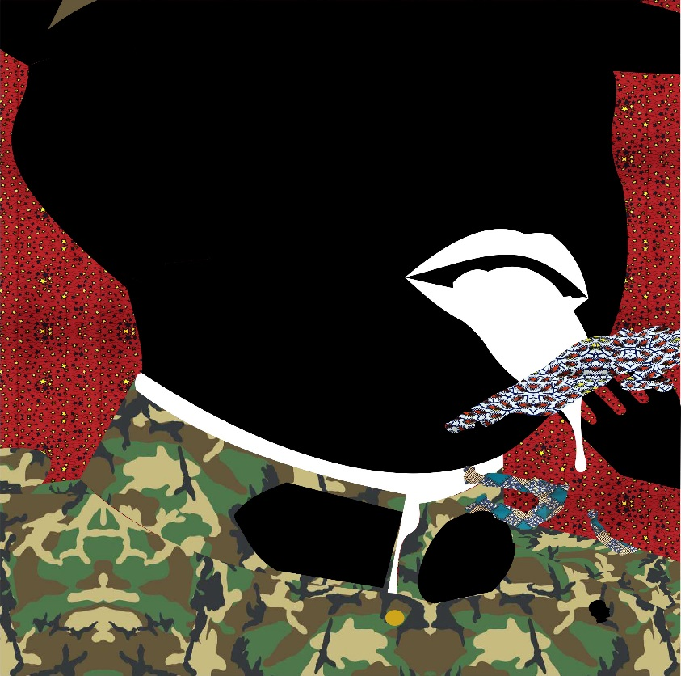
Murtala Muhammed illustration by Sef
Despite Gowon becoming HOS, Murtala’s bloodletting was insatiable. Murtala refused a direct order from the Supreme Military Council (SMC) on different occasions, and would occasionally walk into SMC meetings uninvited. Gowon was afraid of Murtala and tried to avoid him. With Gowon as HOS, the Northern soldiers conducted themselves as overlords. Murtala wanted Ojukwu and the East to grovel, but Gowon wanted a peaceful resolution of the conflicts. Gowon was HOS on one part; Murtala was an unhinged leader on another part. “As Gowon struggled to stabilize himself in power, random murders of Eastern Region soldiers continued to occur. On August 12, several Non-Commissioned-Officers from the Eastern Region were rounded up and killed by Northern soldiers in Apapa, Lagos.” Several summary convictions happened across the nation.
Ojukwu could have at this point declared war on Nigeria, but he was in a tight position. Most of the senior northern officers had trained, schooled, and were close friends with him. The Emir of Kano was in June named the Chancellor of the University of Nigeria, Nsukka, in the East, because of his relationship with Ojukwu. It was in fact, the assurance of Hassan Katsina and the Emir that Ojukwu had told Easterners to return to the North in June, where they were killed en-masse. Ojukwu, feeling part guilty and part angry told all Easterners to return home till there was headway, over 2 million easterners did.
Gowon wanted to negotiate with Ojukwu, and after several attempts, Ojukwu agreed to meet on a neutral ground. They met in Aburi, Ghana. In Aburi, Ojukwu, an enchanting orator was able to convince Nigeria to accept his propositions.
Ojukwu did not agree with Gowon’s elevation above other soldiers to become HOS, and said this would cause problems in the future; it did. At Aburi, Ojukwu propositioned that Nigeria runs a weaker central system, and return to the regional system of Government eliminated by Ironsi. Gowon and the other Nigerian army officers were swayed by Ojukwu until they returned to Lagos when some civil servants explained to Gowon that consenting to the Aburi accord meant he would have lesser power, as powers would be returned to the regions. Pressured by the fear of losing the oil-producing Niger-Delta to Ojukwu’s region, Gowon reneged on his promise. The Aburi accord was futile. In May 1967, the republic of Biafra (formerly Eastern Region of Nigeria) seceded and war broke out in July.

Murtala’s killings continued…

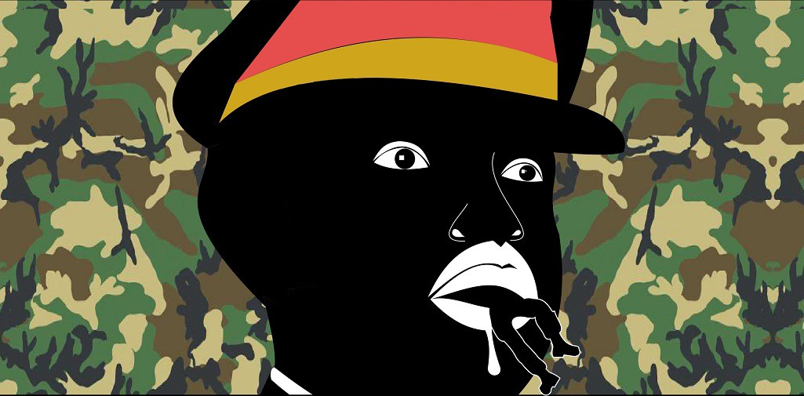
Murtala Muhammed illustration by Sef
Biafrans made the first violent move when they attempted to take over Nigeria’s then Mid-West Region. This move backfired against Biafrans, as Mid-Western and Western sympathy for Biafra dissipated after the attack. Murtala was not satisfied by Nigeria’s slow response. “Murtala through his civilian contacts independently took steps to procure weapons for the impending war.” Nigeria hastily formed a 2 division and made Murtala the GOC. Murtala poached soldiers from other divisions commandeered armoured vehicles and built the new division from scratch. Murtala’s new division had soldiers like Sheu Musa Yar’Adua, Chris Alli, and Sanni Abacha. Murtala’s first task was to reclaim the Mid-West Region from Biafrans, and he did it hastily. But Murtala did not stop after sending Biafran soldiers out of the region, “members of the 2 division carried out a terrible massacre of civilians so grotesque that Gowon had to apologize for it decades after the Civil War. Hundreds of Igbo people in the Mid-West were summarily executed.” If all Nigerians forget, victims of the Mid-West cities of Asaba and Benin will forever remember Murtala’s massacre.
Murtala left the bloodied Mid-West and proceeded to Onitsha. As the last act of protection and isolation, the Onitsha Bridge connecting Mid-West to the East was destroyed by Biafran soldiers. Murtala now had two restrictive routes to get to Onitsha “(a) a dangerous and direct assault via a river crossing, or (b) by crossing the Niger River unopposed via territory held by the neighbouring 1 division, then proceeding overland to Onitsha. Realizing that the dangers and complexities of a direct river-based assault on Onitsha, army headquarters advised Murtala to choose (b).” The arrogant Murtala did not want to cooperate with Lt-Colonel Shuwa, who was his classmate in Zaria and Sandhurst. Murtala did not heed instructions and recommendation from Army HQ, refused the wise counsel of Lt-Col Shuwa, and Lt-Col Frank Aisida (who was one of Murtala’s brigade commanders).
“Murtala proceeded to attack Onitsha via a river crossing even though his navigational instruments were not working, the water level was high, he had no reconnaissance, and most of his troops were not soldiers with combatant missions. These problems were compounded by the fact that most of them could not even swim.” Newly commissioned officers like Oladipo Diya and Ishola Williams were entering their first task in the Nigerian military. They were welcomed by the guns of Biafrans led by Colonel Joe “Hannibal” Achuzia. Murtala will attempt the crossing two more times, losing Nigerian soldiers of mid and low ranks in the attacks. One of his captains died in the assault. Yet, Murtala was not punished for his acts of rebellion. And that wouldn’t be the last time Nigeria would lose brave soldiers because of Murtala.
After his failed attempts at capturing Onitsha, he begrudgingly agreed to cooperate with Shuwa. His indiscipline spilt into his division, and soldiers looted as they proceeded. Murtala would at different times coordinate attacks without planning with Shuwa. In March 1968, Nigeria suffered one of its biggest losses in the war. “An opportunistic Biafran disobeyed orders and fired the single last mortar in the possession of the Biafrans at Murtala’s convoy. The plucky soldier scored a direct hit on a vehicle in the convoy carrying ammunition, which ignited. The resulting fire set the convoy of almost one hundred vehicles ablaze.” Nigeria would have avoided this tragedy if Murtala had taken orders, avoiding the Abagana route that was so narrow, it was difficult to reverse or turn. Murtala was recalled and replaced by Colonel Haruna who struggled to conduct the 2 division and was soon replaced by Colonel Gibson Jalo. Murtala’s indiscipline had seethed deeply that Haruna had to sentence some soldiers to face a firing squad after robbing a Bank in Asaba.
Instead of punishing Murtala, he was promoted to Colonel in April 1968 and Brigadier in October 1971. In 1974, Gowon made Murtala the Inspector of Signals. Murtala still felt aggrieved that power was not shared with him despite ‘bringing’ Gowon to power. Although by the end of the Civil war, Murtala had other preoccupations, his loyalists in the military did not go to sleep.

1975 COUP
It was the one coup that the victim (Gowon) was well informed of and also had adequate time to quell. But Gowon’s popularity was beginning to fade. Despite being seen as Nigeria’s Abraham Lincoln, reneging on his promise to cede power in 1976 tainted his popularity. The coup was executed by the same faction of soldiers that brought Gowon to power, this time led by Colonel Joe Garba, the commander in charge of the elite Brigade of Guards — this is the unit responsible for directly protecting Gowon. The head of Police special branch M.D Yusuf was informed of this coup, and when he told Gowon, he told Yusuf to stand down, that he would confront Garba when he returned from Kampala, where he was going to attend an OAU meeting. The coup had major actors like Sheu Yar’Adua, Ibrahim Taiwo, Muktar Mohammed, Alfred Aduloju, Paul Tarfa, Sani Bello, Ibrahim Babangida, and Muhammadu Buhari.
Murtala Muhammed did not participate in the coup, but he was visited by Yar’Adua and Garba, who met to inform him of the plot and ‘convince’ him to become HOS. Murtala said little; shared his resentment for Gowon, and gave the plotters his support, promising to protect them in case the coup was foiled. Other top officers in the military were informed and were told to either look the other way or be killed if they attempted to prevent the coup.
On the day the coup was to take place, Murtala himself was in London. It was a bloodless takeover. By 2 a.m., the Lagos airport was sealed off and all roads to the airport shut. Communications were severed. Gowon was informed that he had been usurped while the General Assembly of the 12th OAU congregation was in session. The next challenge was announcing the next HOS.
The plotters decided the 3 of their superior officers; Brigadiers Obasanjo, T.Y Danjuma, and Murtala Muhammed would form a troika government. Murtala’s plane was allowed to return to Lagos from London, and he furiously objected to the power-sharing system the coup plotters devised. Murtala did not want to answer to anyone. The coup plotters knew that Murtala commanded support from combatant soldiers, and threatened Murtala that if he refused to be the HOS on the power-sharing terms, they would tell everyone the outcome of their meeting, and select someone else as HOS. Murtala was angry and bitter, but eventually agreed to share power with Obasanjo and Danjuma, and any decision of the SMC that lacked two-third majority support would not be executed. Murtala was outwitted.

Head of State Murtala

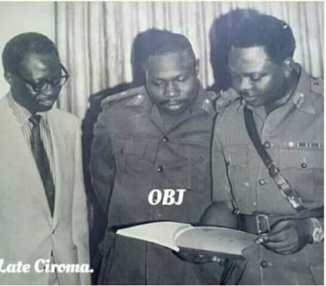
Adamu Ciroma, Olusegun Obasanjo, Murtala Muhammed
In the archetypal Nigerian leadership format, Murtala’s former sins were forgotten. Murtala immediately restructured the SMC, retiring superior officers, and promoting coup profiteers. Security chiefs were changed. Murtala opposed the appointment of M.D Yusuf as IGP, because Yusuf had informed Gowon about the coup that brought Murtala to power, but it wasn’t a solo government. M.D Yusuf became IGP.
“It was clear from the outset that Murtala’s governing style would be a stark contrast to that of Gowon. While Gowon was diplomatic, conciliatory and cautious, Murtala was brisk, volatile and displayed decisiveness with major issues that bordered on impulse.” To his credit, Murtala’s leadership style prompted civil servants to be upright in their duties. Murtala also retired ten of the twelve military administrators who were found guilty of enriching themselves. Under Gowon, Military Governors formed the executive and legislative arm of government by their positions in the Supreme Military Council; Murtala curbed their powers by pushing them out of the SMC, allowing for proper separation of power. Murtala also had Governors serve in a region other than their region of origin. Asides Sheu Shagari (finance) and Ali Monguno (mines and power), all Federal Commissioners were found guilty of corruption, sacked, and government assets reclaimed from them. Murtala also sacked over 10,000 civil servants who fell into the old, inefficient, or corrupt categorization. On the international front, Murtala maintained a non-aligned posture towards the cold war. Murtala meant business.
“ALL THE WORLD IS A STAGE”
For the first time in Nigeria’s post-colonial history, Nigeria was led by a strict disciplinarian who did not look to anyone for counsel or look to favour anyone. This made many Nigerians become upright as everyone was afraid of being hit by Murtala’s mace of discipline. But Murtala soon made his first mistake. In January 1976, he approved a wave of promotions in the military that was bizarre and unnecessary. These promotions’ bizarre nature was soon exposed when many officers realized that officers that were junior to them were suddenly their seniors. Many officers were unhappy with this decision.
His second mistake was his refusal to take his security seriously. Murtala did not use a motorcade like most Nigerian HOS and did not move into the Statehouse. He continued to live in his Ikoyi residence. While commuting to work in his Mercedes Benz saloon car on Friday the 13th, 1976, a group of mutineers waylaid Murtala and opened fire on his car. The mutineers were so aggressive that one of them emptied an entire magazine, reloaded, and re-fired. The coup was led by Lt-Colonel B.S Dimka, one of the mutineers of the July 1966 counter-coup. It was the third time that a faction from the 1966 mutineers would attempt to take power from a sitting HOS. It wouldn’t be the last.

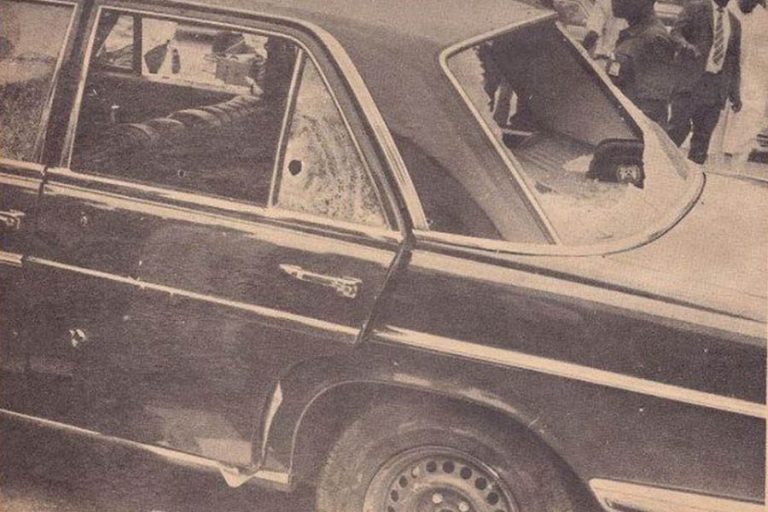
The Car Murtala was assassinated in

This is the first story in a series chronicling the lives of various Nigerian HOS who have become martyred by time and Nigeria’s political whitewashing. More stories to come. Follow SM conversations with ‘#NigeriaWWHOS’, ‘#Know9jaHistory’.
Attribution
The sentences and paragraphs quoted are from the same author, Max Siollun specifically because of the well-detailed chronology of his trilogy;
i) Oil, Politics and Violence, Nigeria’s military coup culture (1966–1976)
ii) Soldiers of Fortune; Nigerian politics from Buhari to Babangida (1983–1993)
iii) Nigeria’s soldiers of fortune; The Abacha and Obasanjo years
Additional reading and references for this series can be found in;
i) The last 100 days of Abacha by Olusegun Adeniyi
ii) The tragedy of Victory by Brigadier-General Alabi Isama
iii) Nzeogwu by Olusegun Obasanjo
iv) My command by Olusegun Obasanjo
v) Why we struck by Adewale Ademoyega
vi) The Making of an African Legend: The Biafra Story by Frederick Forsyth
vii) Murtala Muhammed: Architect of Modern Nigeria by Umar Ardo
viii) The Nigerian Civil War and its Aftermath: Osaghae, E. et.al.
…And a host of other books on the Nigerian Civil war, and the Military coups surrounding Nigeria’s terse history.

